9/22/2026
Instructor: Sir M. Fahad Qasim
Submitted by: Wasif Ali
Reg id: 245187
Class: BSCS F24 B


HTML
Full-Stack Development Lab
Lab No 02
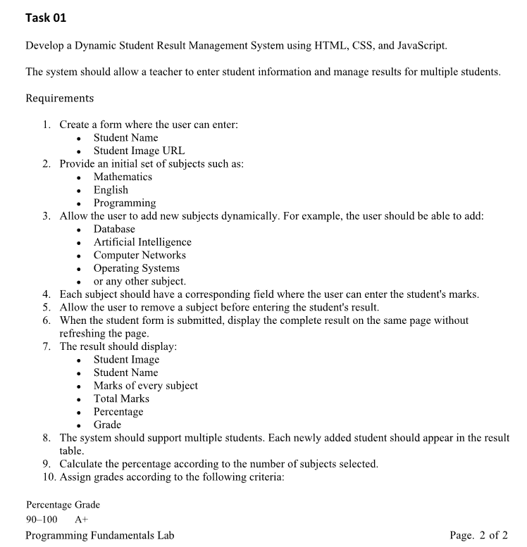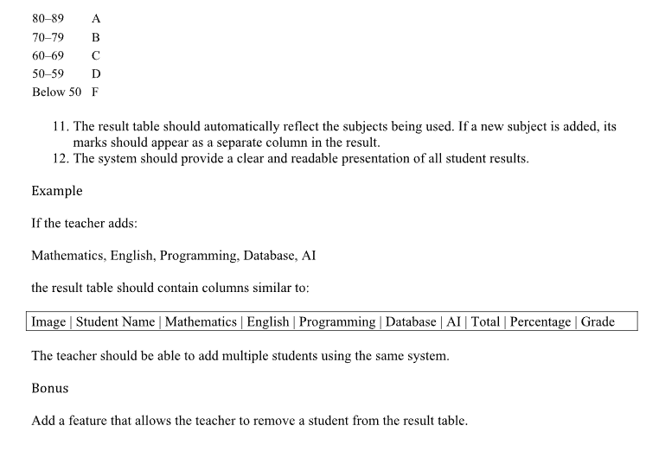

Code:
<!DOCTYPE html>
<html>

<head>
<title>Student Result System</title>
<style>
body {
font-family: Arial, sans-serif;
margin: 20px;
}

h2 {
background-color: #f0f0f0;
padding: 10px;
font-weight: normal;
border-radius: 4px;
}

input,
button {
padding: 6px;
margin-right: 10px;
margin-bottom: 15px;
border: 1px solid #a9a9a9;
border-radius: 2px;
}

.sub-row {
margin-bottom: 10px;
}

.sub-row span {
display: inline-block;
width: 120px;
}

.sub-row input {
width: 80px;
margin-bottom: 0;
}

.sub-row button {
padding: 4px 10px;
}

table {
width: 100%;
border-collapse: collapse;
margin-top: 10px;
}

th,
td {
border: 1px solid #a9a9a9;
padding: 8px;
text-align: center;
}

th {
background-color: #f9f9f9;
font-weight: normal;
}
</style>
</head>

<body>

<h2>Student Result System</h2>

<form id="myForm">
<div>
<input id="stdName" required placeholder="Student Name">
<input id="stdPic" type="url" required placeholder="Image URL">
</div>

<div>
<input id="newSub" placeholder="New Subject Name">
<button type="button" id="addBtn">Add Subject</button>
</div>

<p><b>Enter Marks:</b></p>
<div id="subInputs"></div>

<br>
<button type="submit">Submit Your Result</button>
</form>

<table>
<thead id="headRow"></thead>
<tbody id="bodyRows"></tbody>
</table>

<script>
let mySubjects = ["Math", "English", "Programming"];
let myStudents = [];

function updateScreen() {
let formDiv = document.getElementById("subInputs");
let tHead = document.getElementById("headRow");
let tBody = document.getElementById("bodyRows");

formDiv.innerHTML = "";
for (let i = 0; i < mySubjects.length; i++) {
formDiv.innerHTML += `
<div class="sub-row">
<span>${mySubjects[i]}:</span>
<input type="number" id="mark_${i}" required>
<button type="button" onclick="deleteSub(${i})">x</button>
</div>`;
}

tHead.innerHTML = `<tr><th>Image</th><th>Name</th>`;
for (let i = 0; i < mySubjects.length; i++) {
tHead.innerHTML += `<th>${mySubjects[i]}</th>`;
}
tHead.innerHTML += `<th>Total</th><th>%</th><th>Grade</th><th>Action</th></tr>`;

tBody.innerHTML = "";
for (let i = 0; i < myStudents.length; i++) {
let std = myStudents[i];
let rowHtml = `<tr>
<td><img src="${std.pic}" width="30"></td>
<td>${std.name}</td>`;

for (let j = 0; j < mySubjects.length; j++) {
let m = std.marks[mySubjects[j]];
if (m == undefined) m = "-";
rowHtml += `<td>${m}</td>`;
}

rowHtml += `<td>${std.totalMarks}</td>
<td>${std.percentage}</td>
<td>${std.grade}</td>
<td><button type="button" onclick="deleteStd(${i})">x</button></td>
</tr>`;

tBody.innerHTML += rowHtml;
}
}

document.getElementById("addBtn").addEventListener("click", function () {
let val = document.getElementById("newSub").value;
if (val != "" && mySubjects.includes(val) == false) {
mySubjects.push(val);
document.getElementById("newSub").value = "";
updateScreen();
}
});

document.getElementById("myForm").addEventListener("submit", function (event) {
event.preventDefault();

let studentMarks = {};
let total = 0;

for (let i = 0; i < mySubjects.length; i++) {
let m = Number(document.getElementById("mark_" + i).value);
studentMarks[mySubjects[i]] = m;
total = total + m;
}

let per = total / mySubjects.length;

let g = "F";
if (per >= 90) { g = "A+"; }
else if (per >= 80) { g = "A"; }
else if (per >= 70) { g = "B"; }
else if (per >= 60) { g = "C"; }
else if (per >= 50) { g = "D"; }

let newStudent = {
name: document.getElementById("stdName").value,
pic: document.getElementById("stdPic").value,
marks: studentMarks,
totalMarks: total,
percentage: per.toFixed(1),
grade: g
};

myStudents.push(newStudent);
document.getElementById("myForm").reset();
updateScreen();
});

function deleteSub(index) {
let tempArray = [];
for (let i = 0; i < mySubjects.length; i++) {
if (i != index) tempArray.push(mySubjects[i]);
}
mySubjects = tempArray;
updateScreen();
}

function deleteStd(index) {
let tempArray = [];
for (let i = 0; i < myStudents.length; i++) {
if (i != index) tempArray.push(myStudents[i]);
}
myStudents = tempArray;
updateScreen();
}

updateScreen();
</script>
</body>

</html>

OUTPUT:
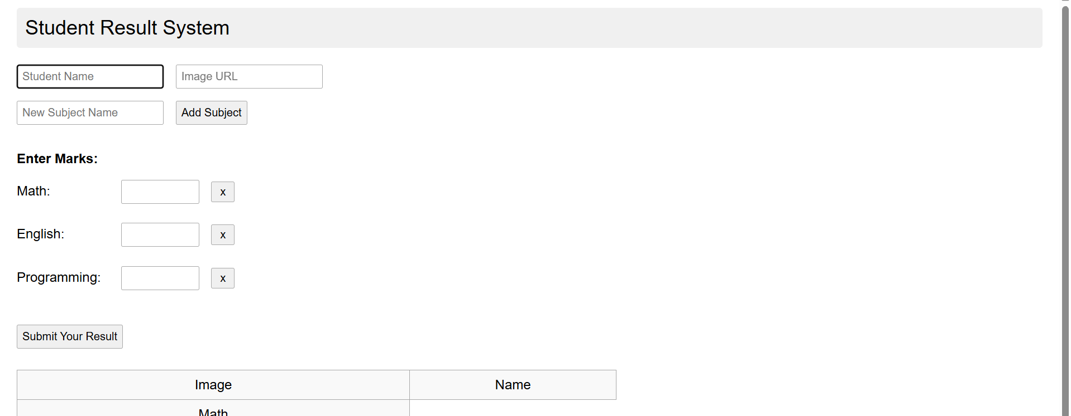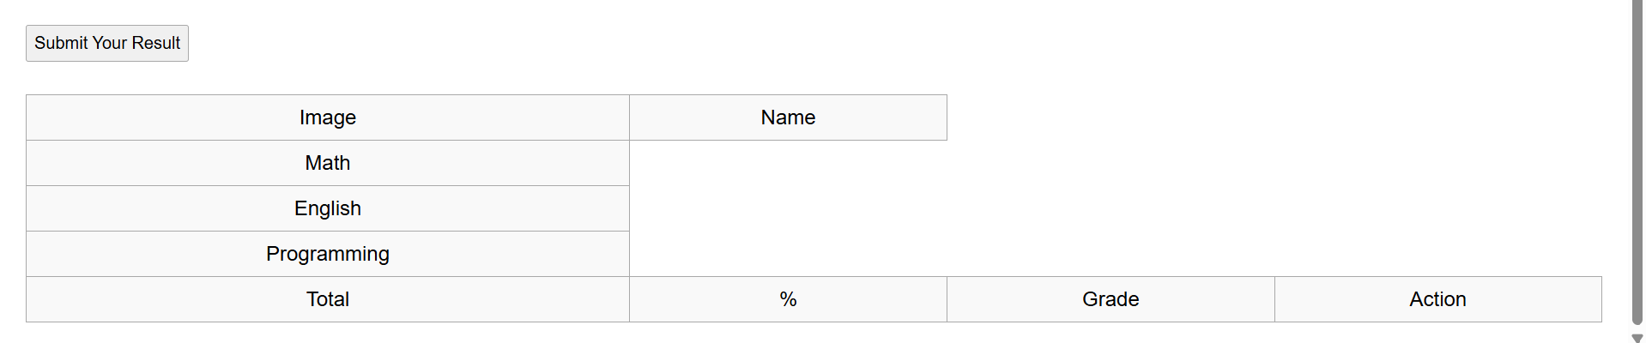
After adding records:
